|  |  |
| --- | --- |
| **Date** | 15th April 2023 |
| **Team ID** | NM2023TMID16774 |
| **Project Name** | Retail Management Application Using Salesforce |
| **Team Lead** | Sneka v |
| **Team Member** | Santhiya M  Ranjani P  Srimathi J |

**Retail Management Application Using Salesforce**

**1.**  **INTRODUCTION**

**1.1 Overview**

Our projects aim to improve the functionality of an existing Retail Management for the salesforce. We achieve this goal by all the steps required to bring the customers into the store and fulfil their buying needs. Our project makes shopping a pleasurable experience and ensures the customers leave the store with a smile. In simpler words, retail management help customers shop without any difficulty.

**1.2 Purpose**

Salesforce can be used to manage orders from retail stores and distributors, including tracking orders, processing payments, and managing inventory levels.

This can help field sales teams ensure that orders are fulfilled quickly and accurately and that inventory levels are maintained at optimal levels.

**2. PROBLEM DEFINITION AND DESIGN THINKING**

**2.1 Empathy Map**

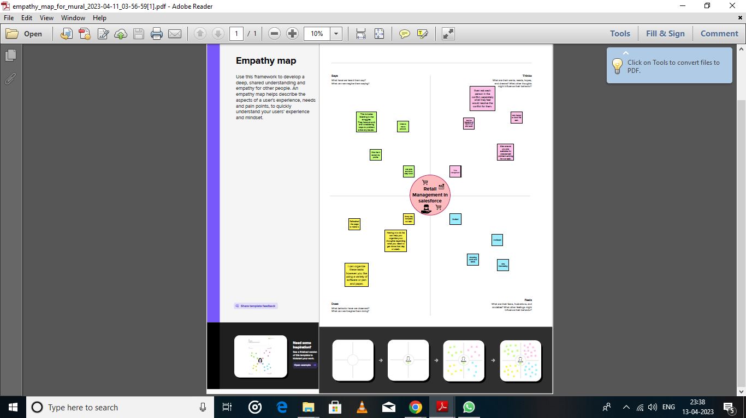

**2.2 Ideation and Brainstorming Map**

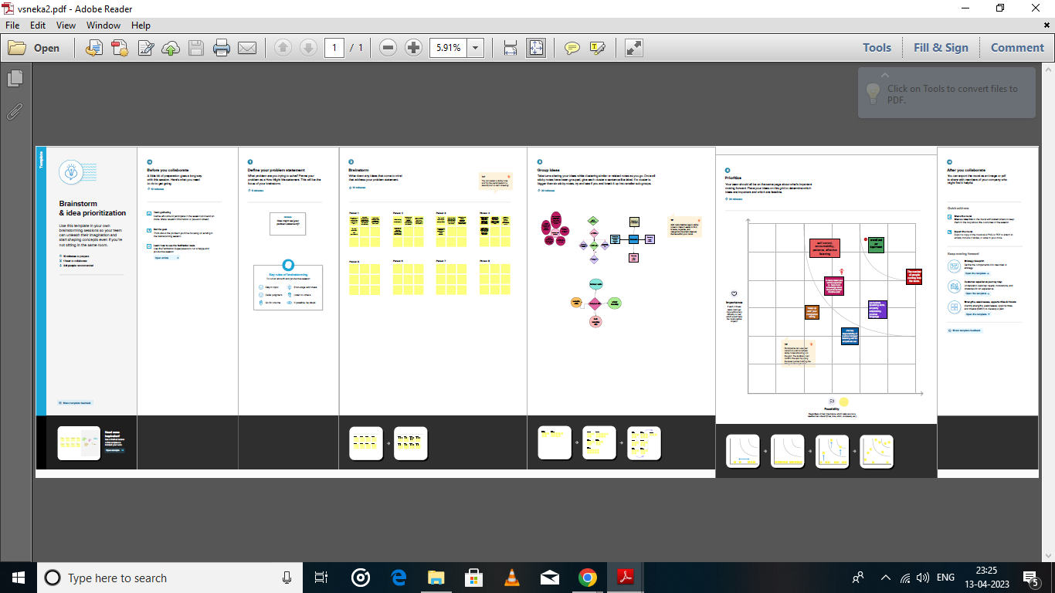

**3 RESULT**

**3.1 Data Model**

|  |  |  |
| --- | --- | --- |
| **Application** | **Object** | **Description** |
| Sales app | campaign | We do promotions by using this object |
| Leads | We capture leads here |
| Accounts | We capture customers data |
| Contacts | Employees data of customer |
| Opportunities | SMB sales orders data |
| Products | Here we store product details i.e electronic types |
| Warehouse | We capture stocks data |
| Sales order | This is an actual order which has invoice details |
| Dispatch/Tracking | Orders dispatch related info will be stored here |
| Service app | Cases | Historical problems of customers will be stored here |
| Accounts | We captures customers data |

**3.2 ACTIVITY AND SCREENSHOT**

**Milestone 1:**

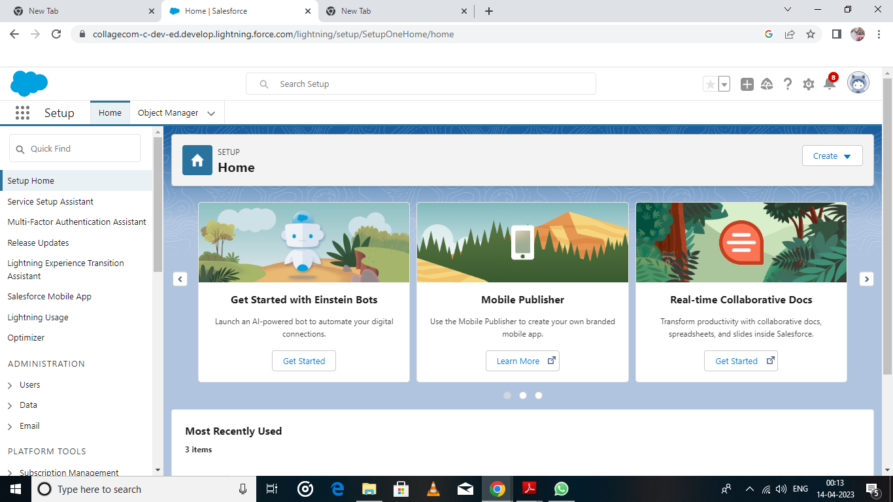 **Creation of Salesforce Account**

**Milestone 2:**

**Activity-1**

**Creation of Object Dispatch/Tracking**

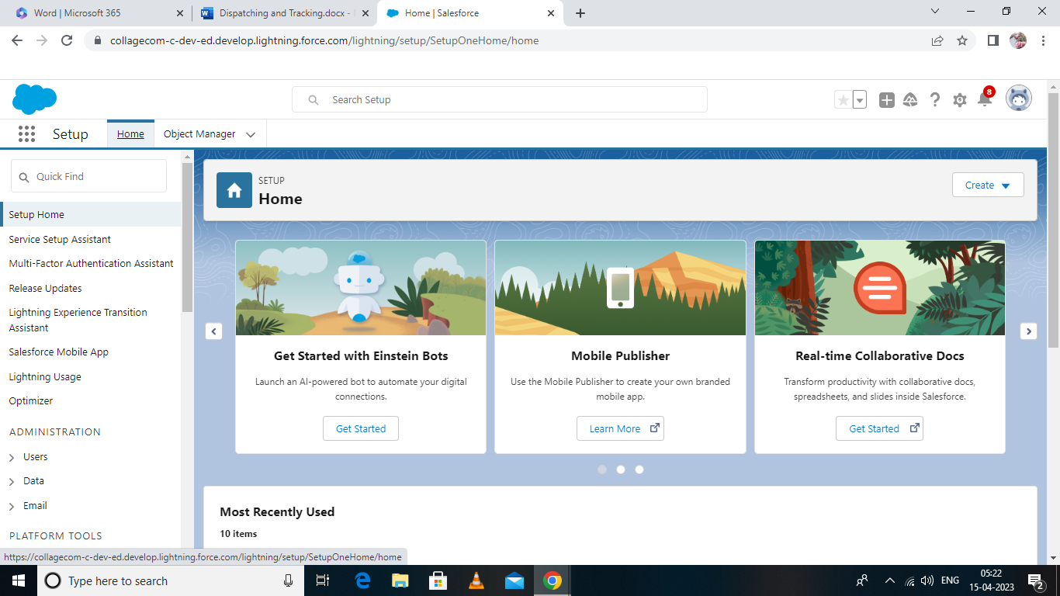

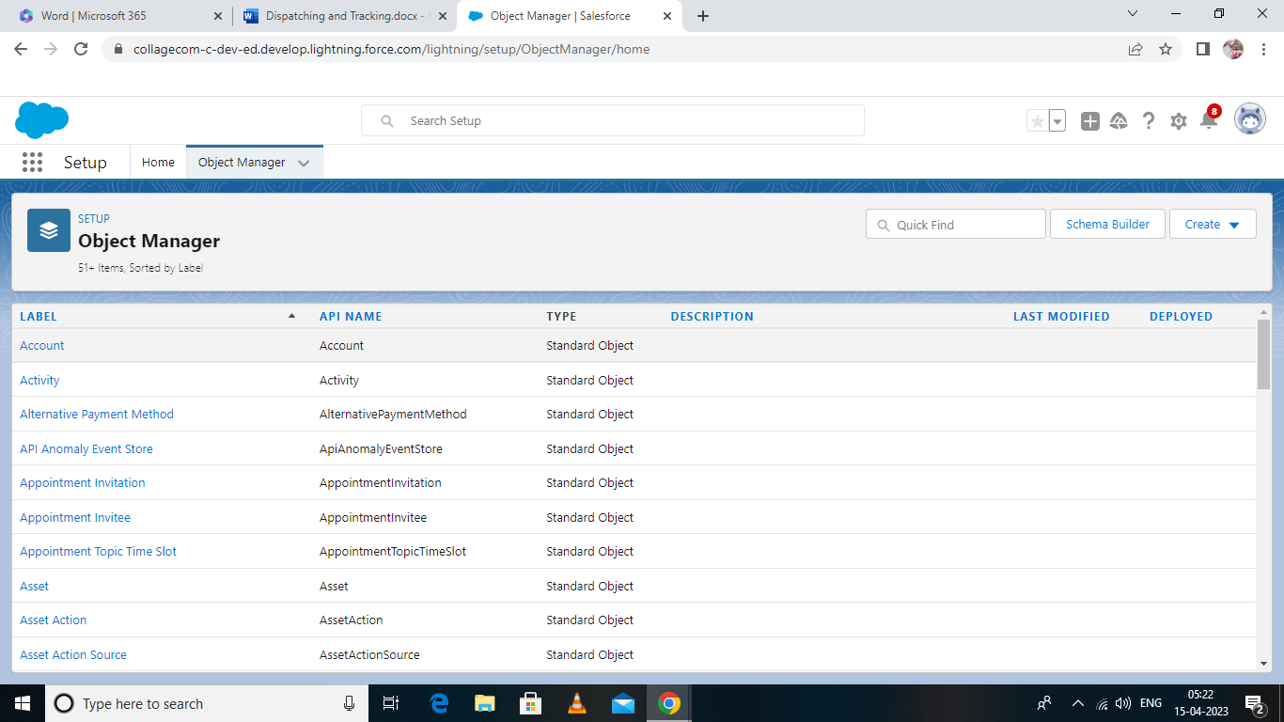

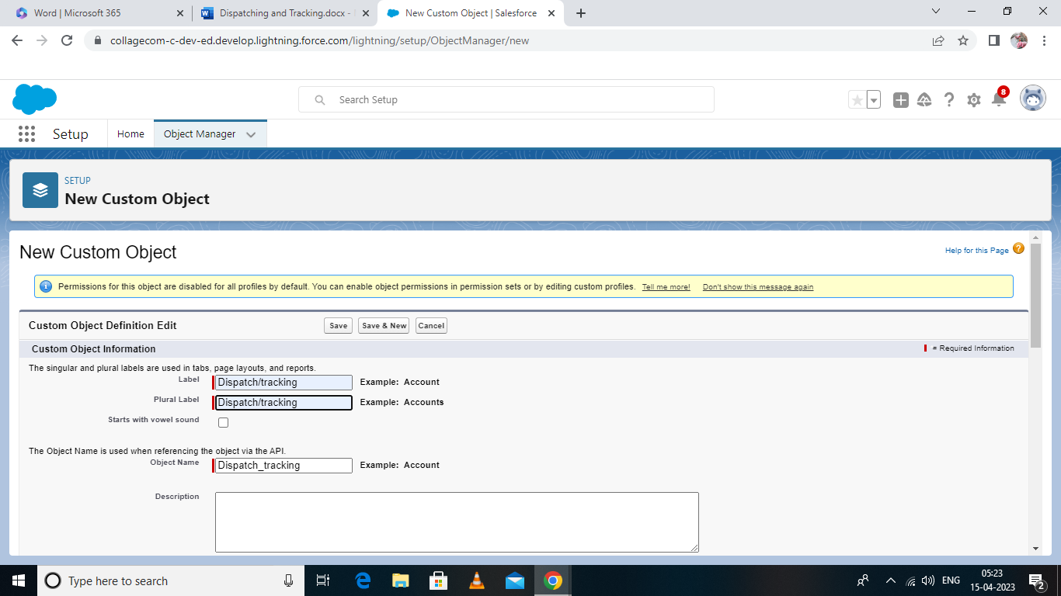

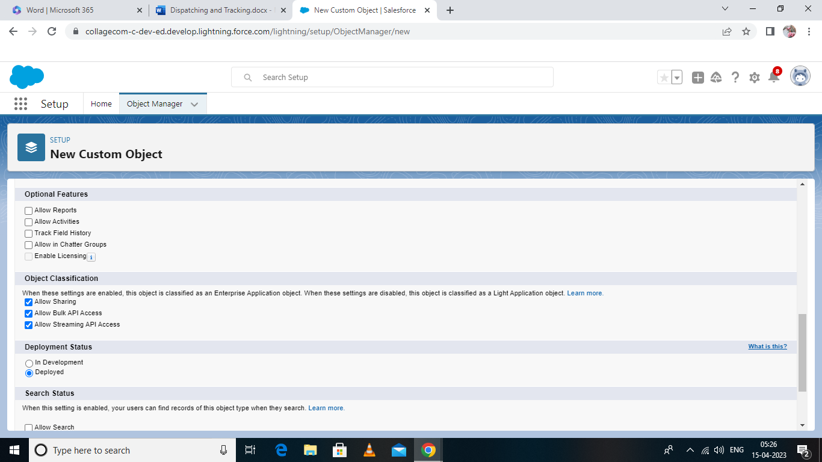

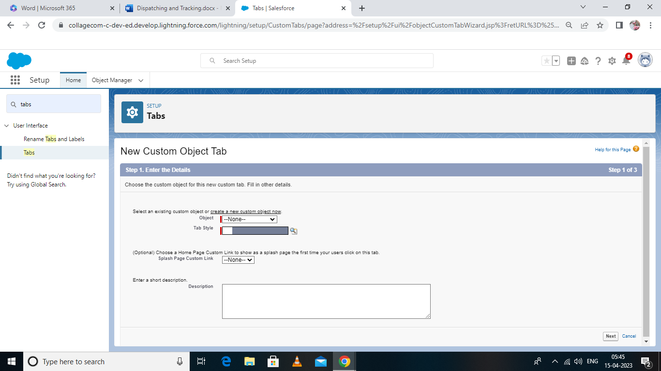

**Activity-2 Fields available on Dispatch/tracking**

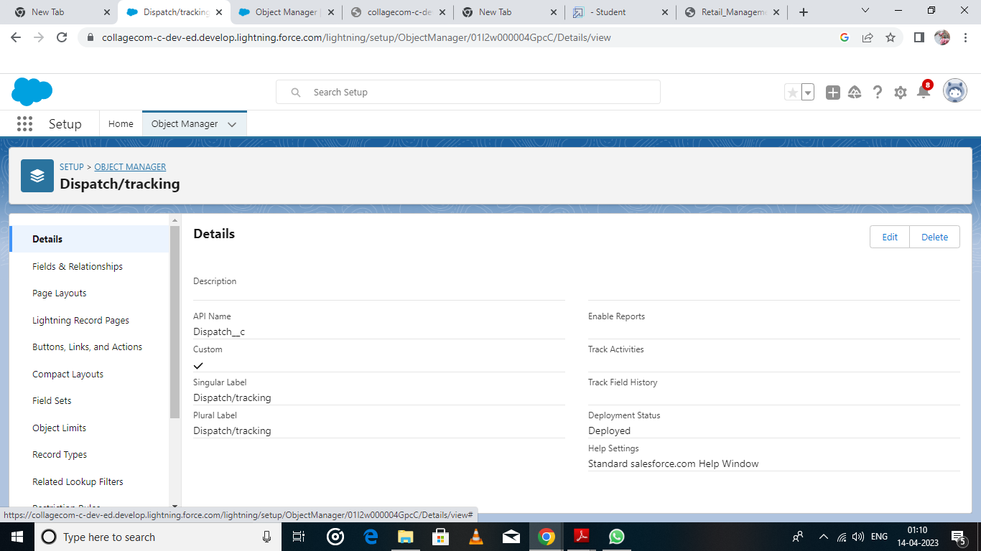

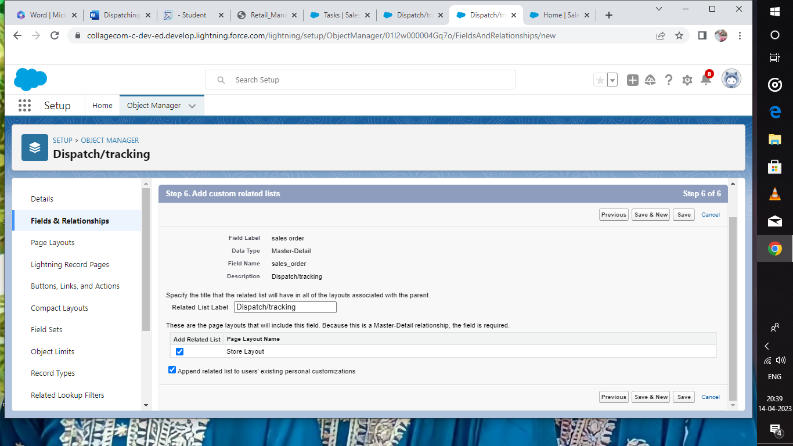

**Creation of Objects (Dispatch/Tracking)**

**Milestone- 3 Relationship b/w objects:**

**Activity-1**

**Creation of relationships between objects**

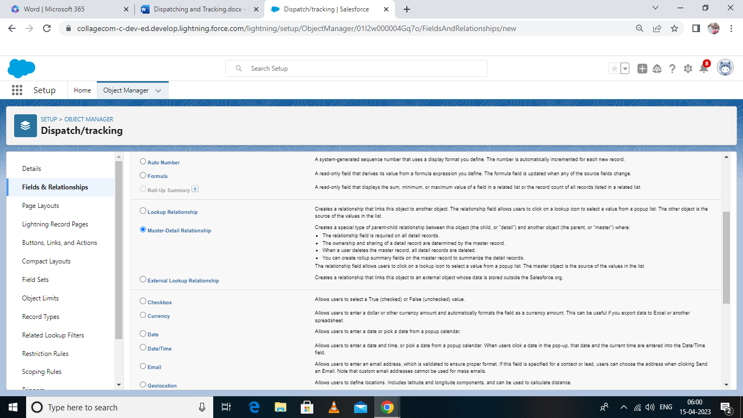

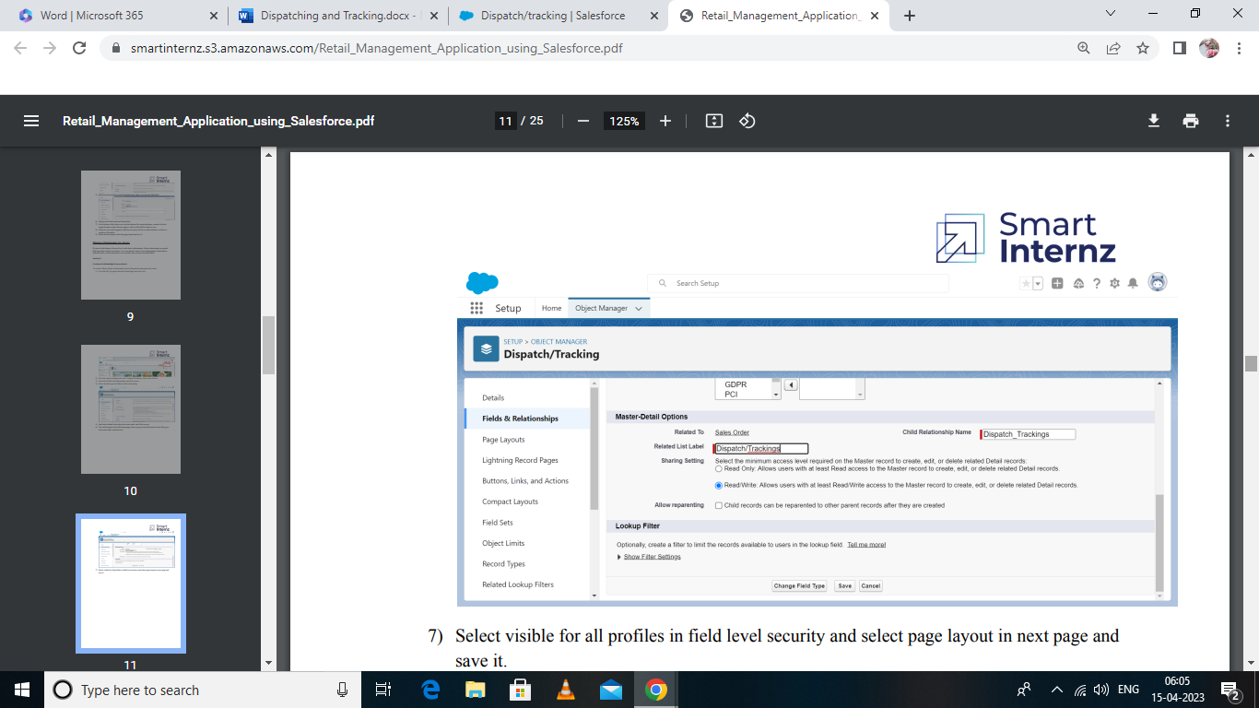

**Milestone- 4 Application:**

**Activitity-1:**

Creation of Application

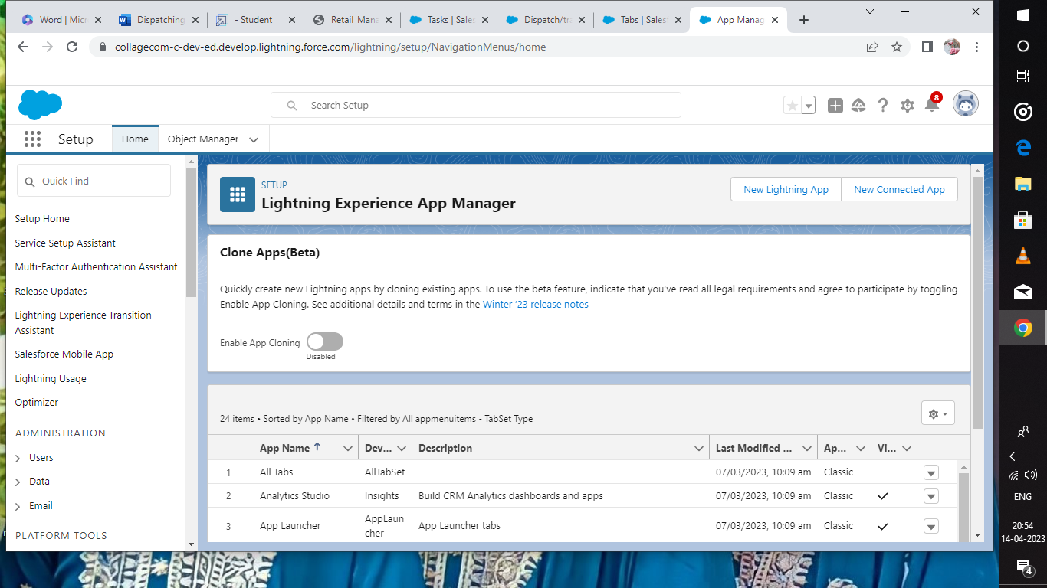

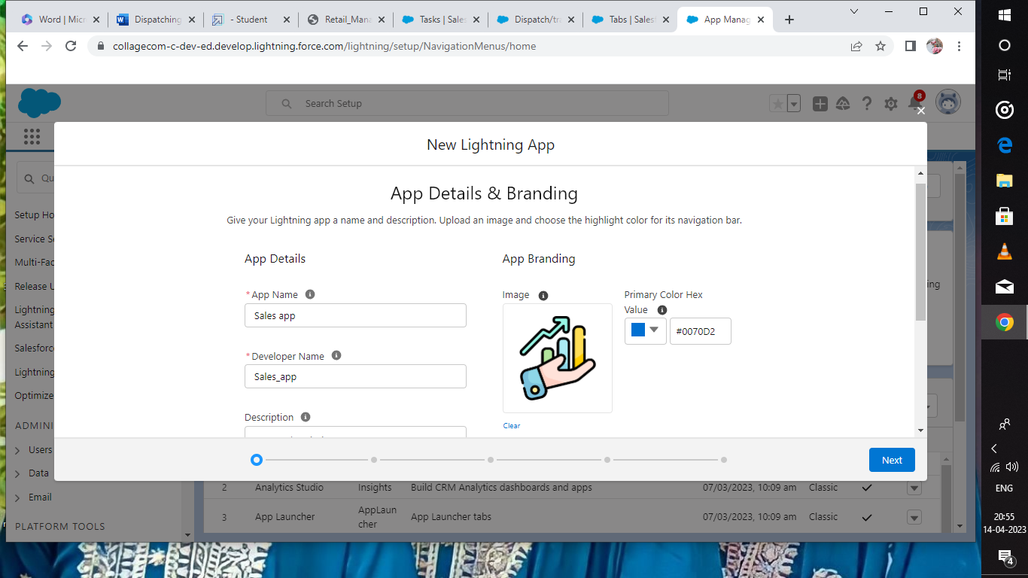

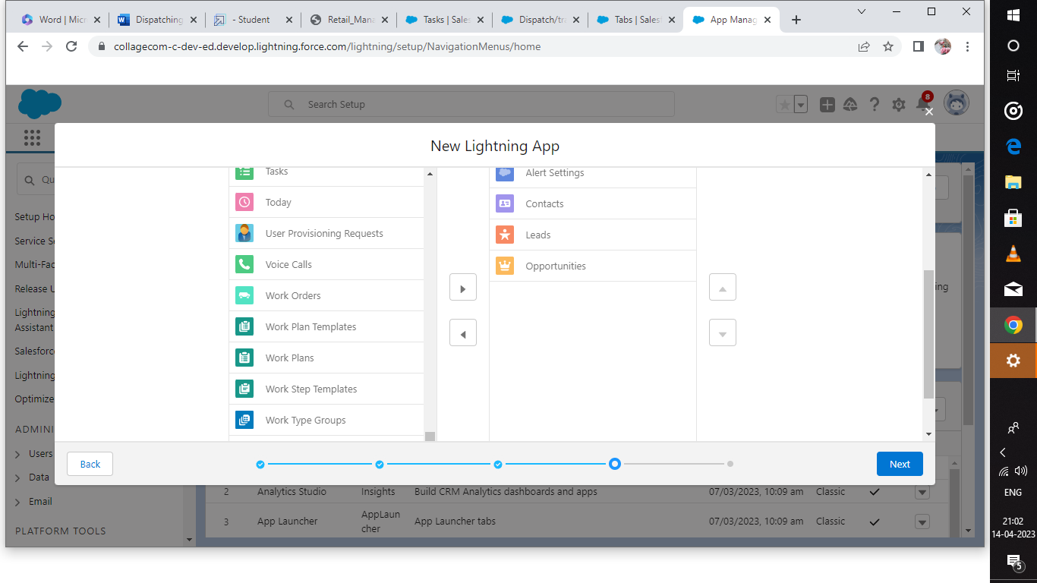

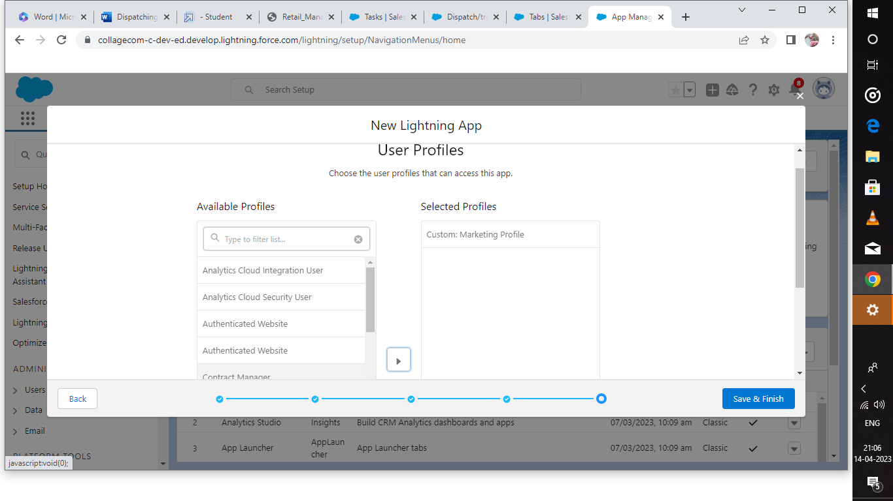

**Milestone-5 Layouts:**

Activity-1:

Creation of custom Tabs

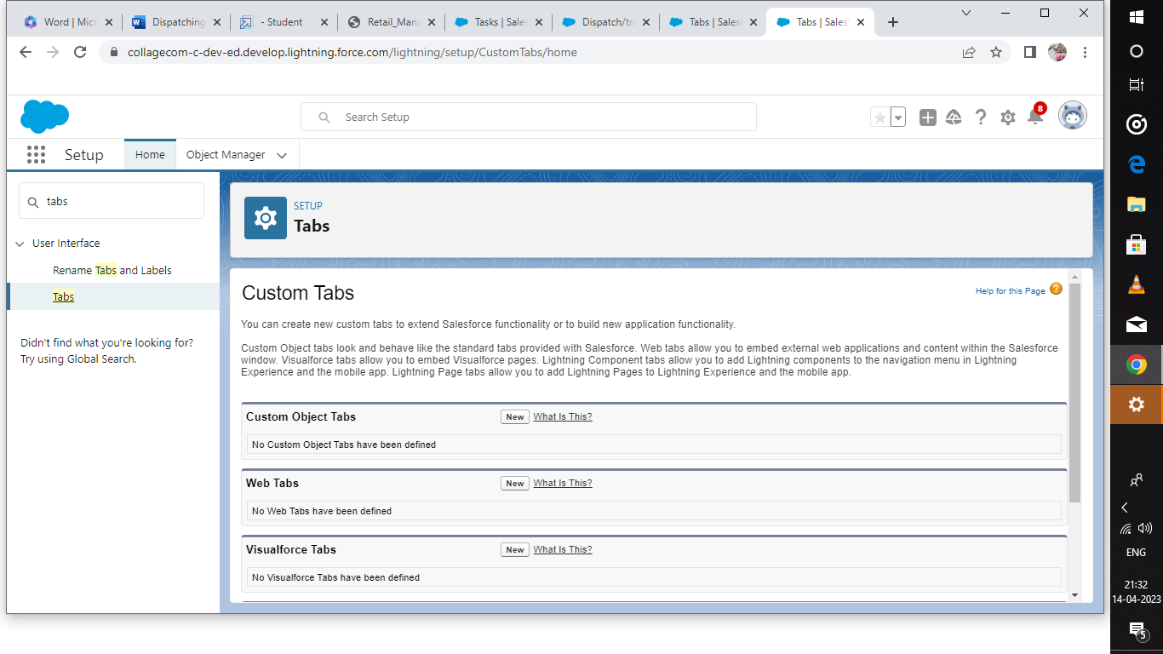

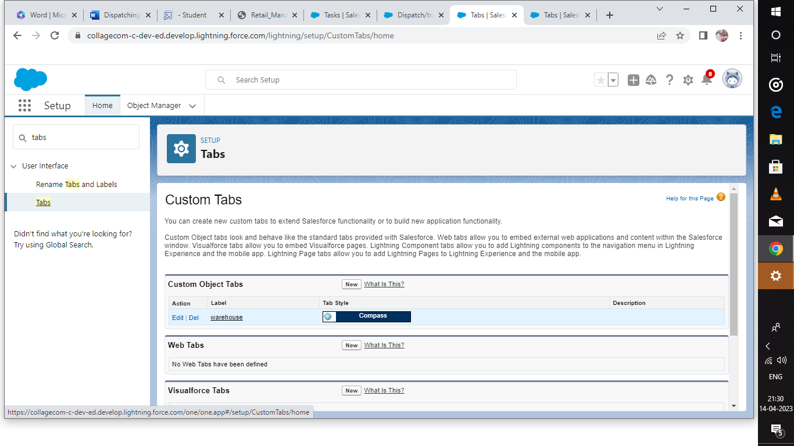

**Milestone –6 User:**

**Activity-1:**

Creation of user

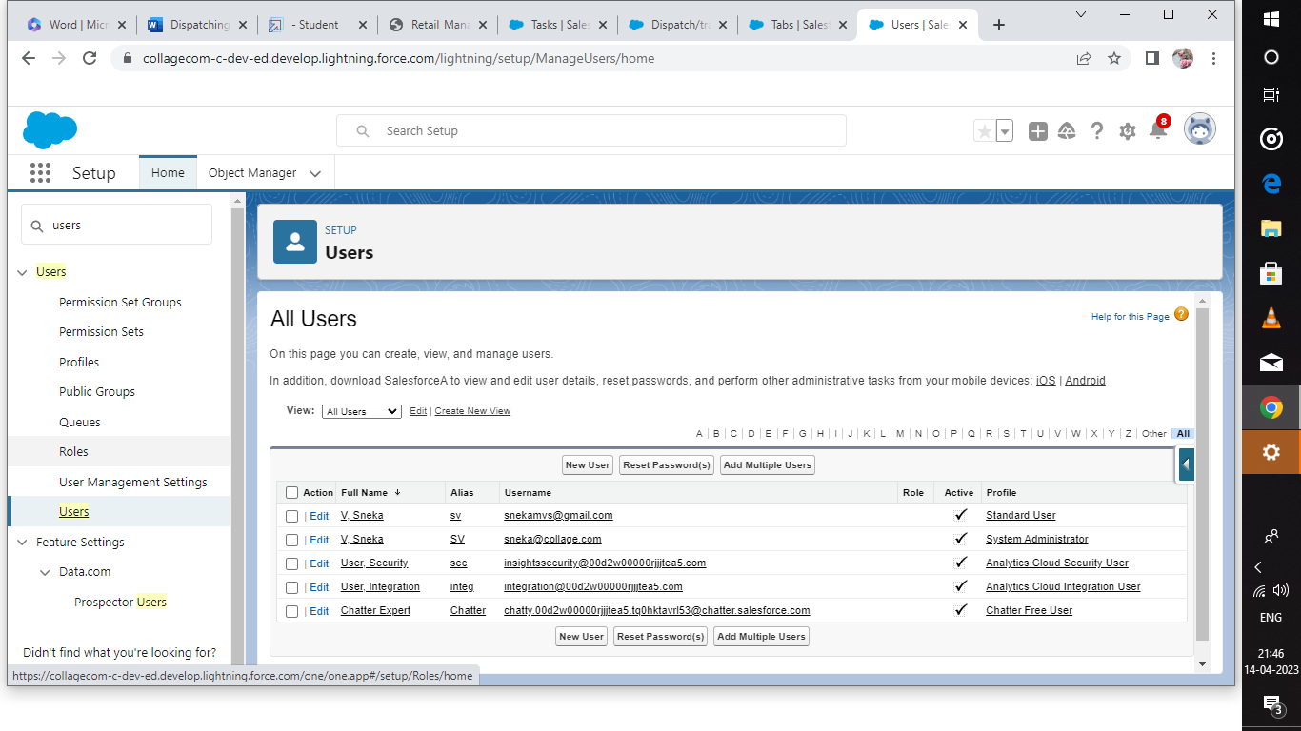

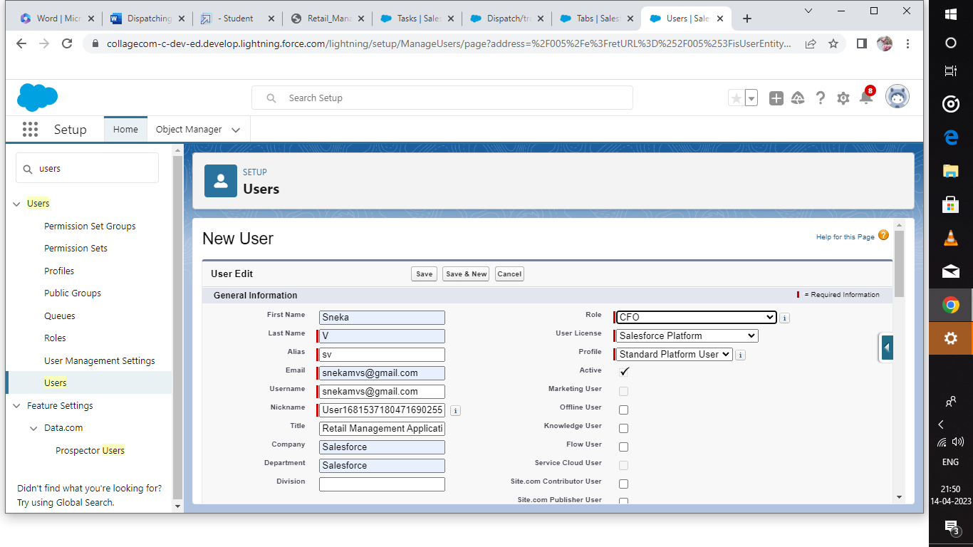

**Milestone-7 Validation Rules:**

**Activity-1:**

**Creation of validation rule**

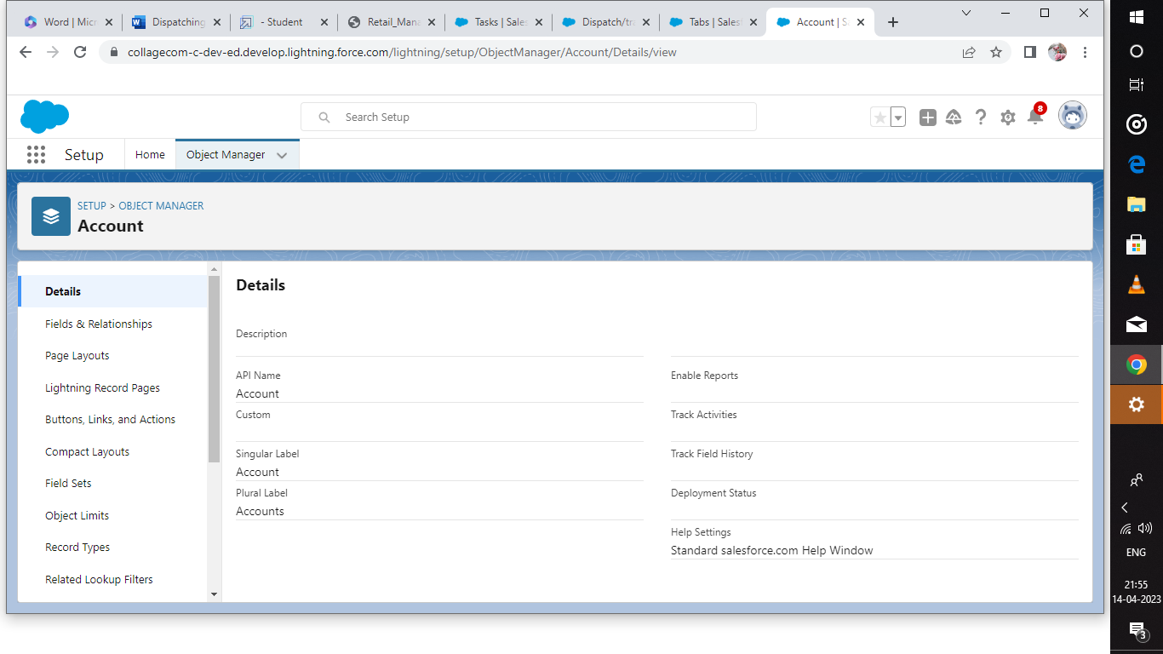

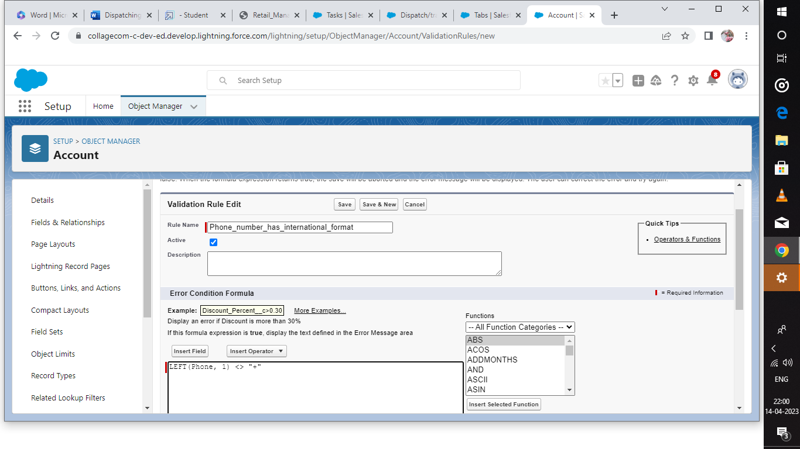

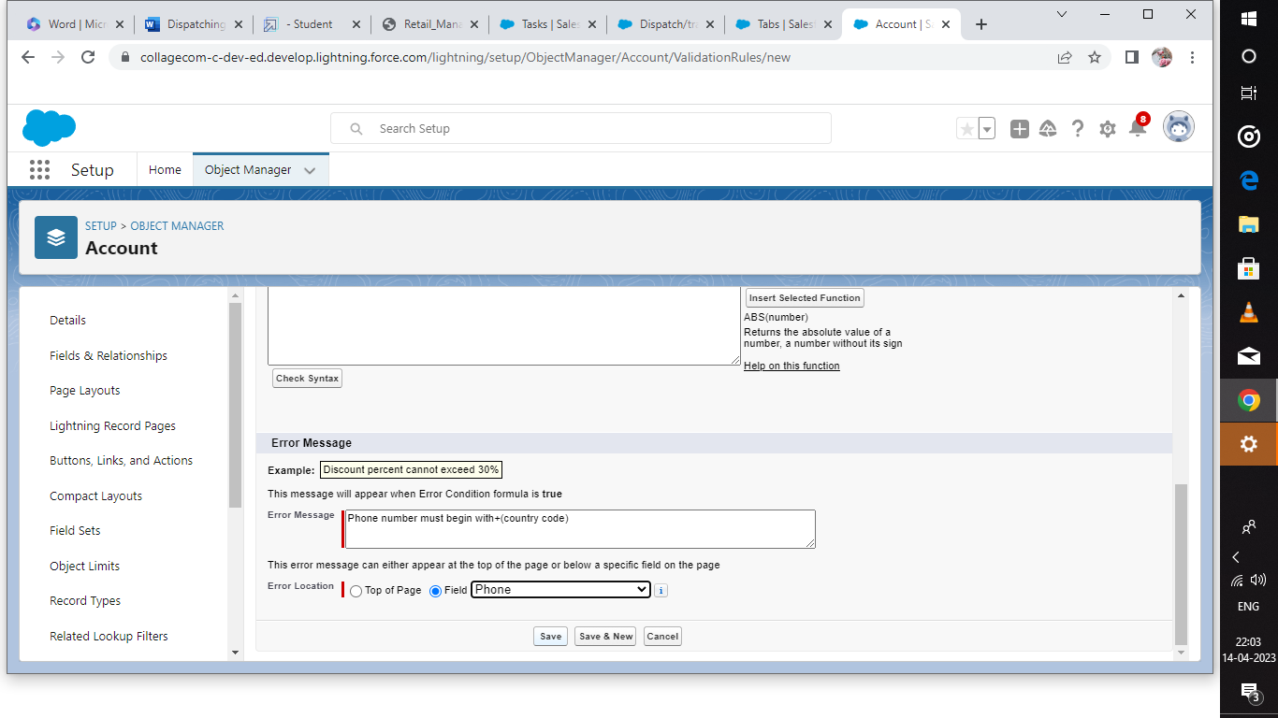

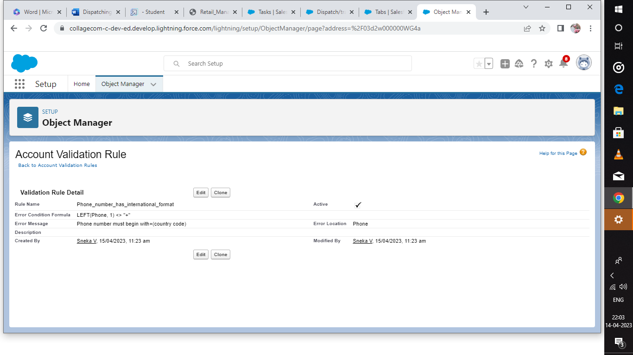

**Activity-2:**

**Cross Object Formula**

**Creation of cross object**

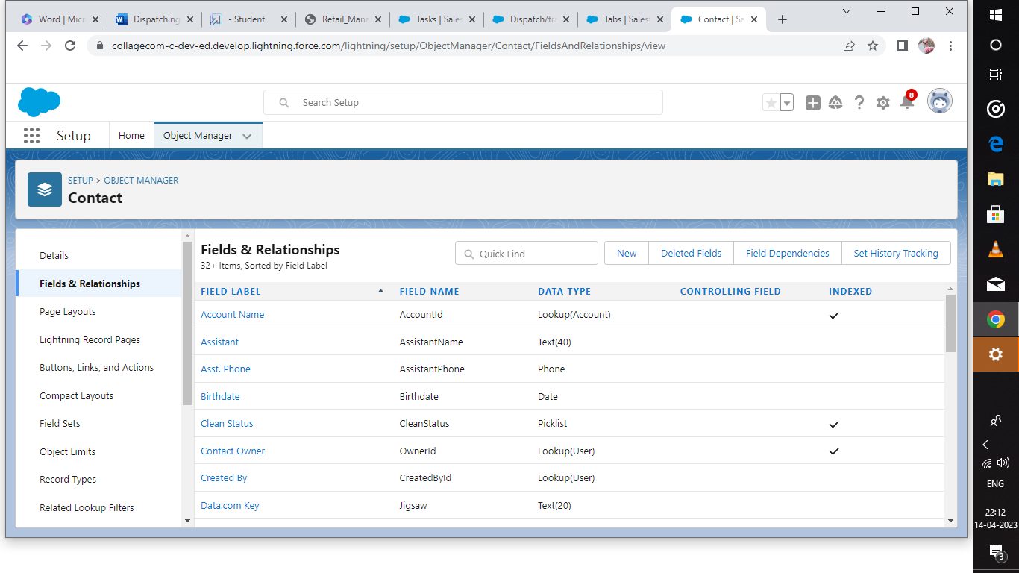

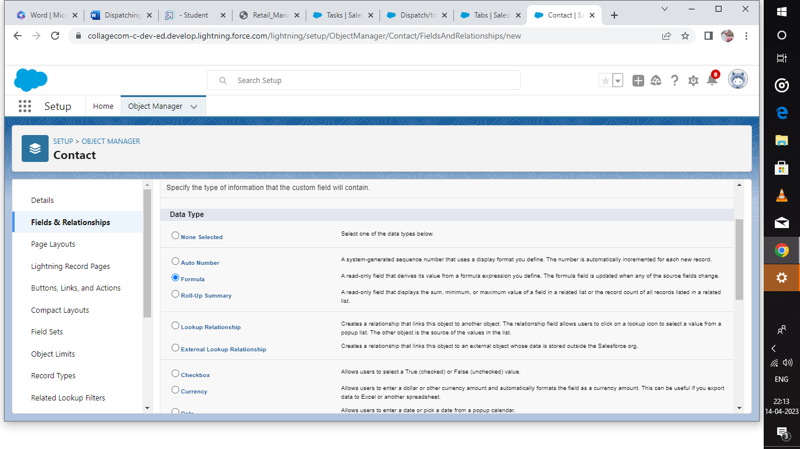

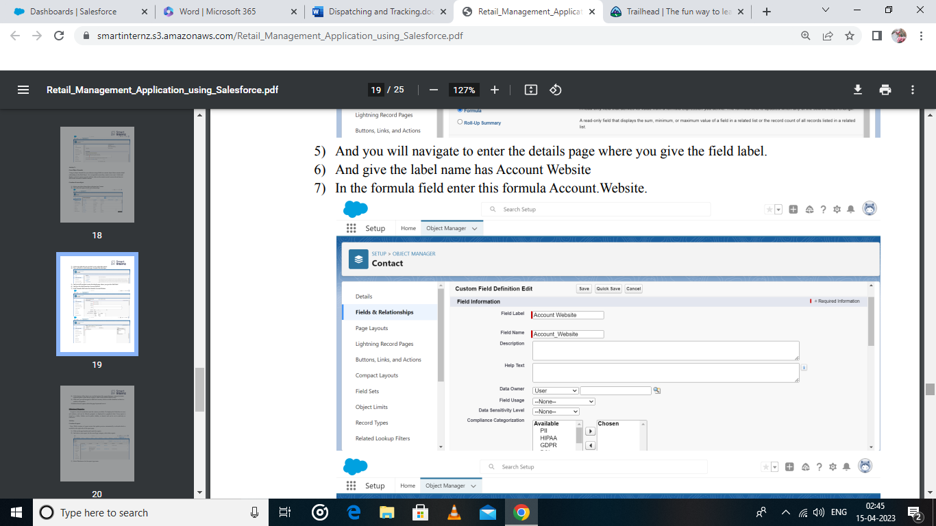

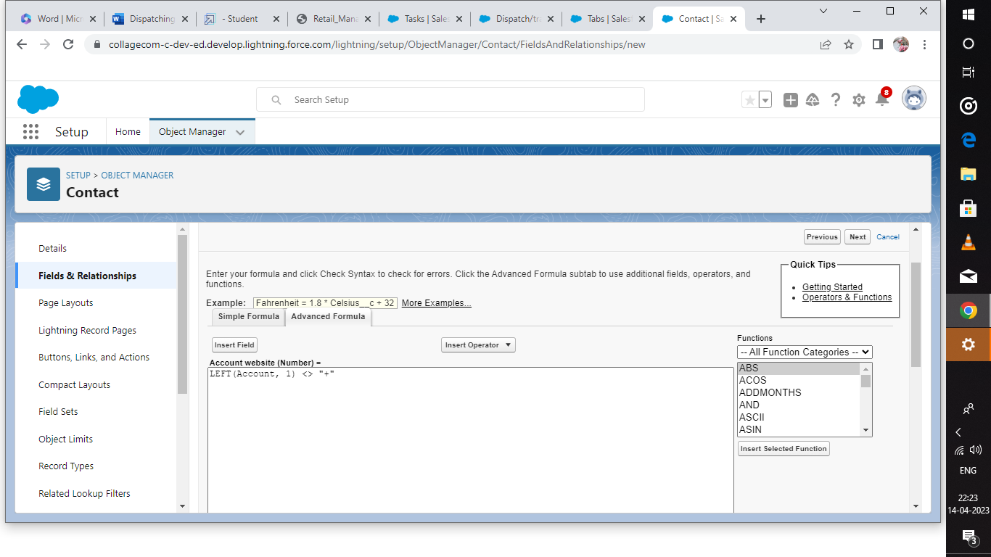

**Milestone-7 Reports**

**Activity:**

**Creation of report**

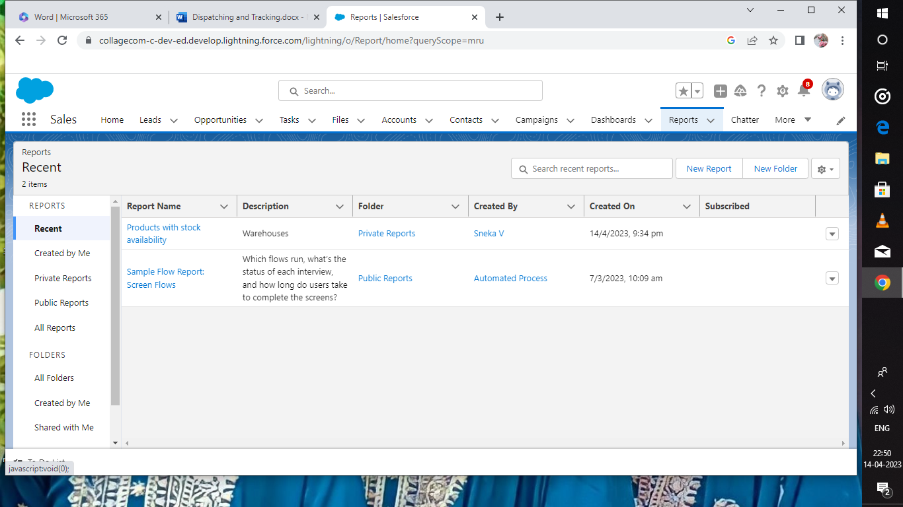

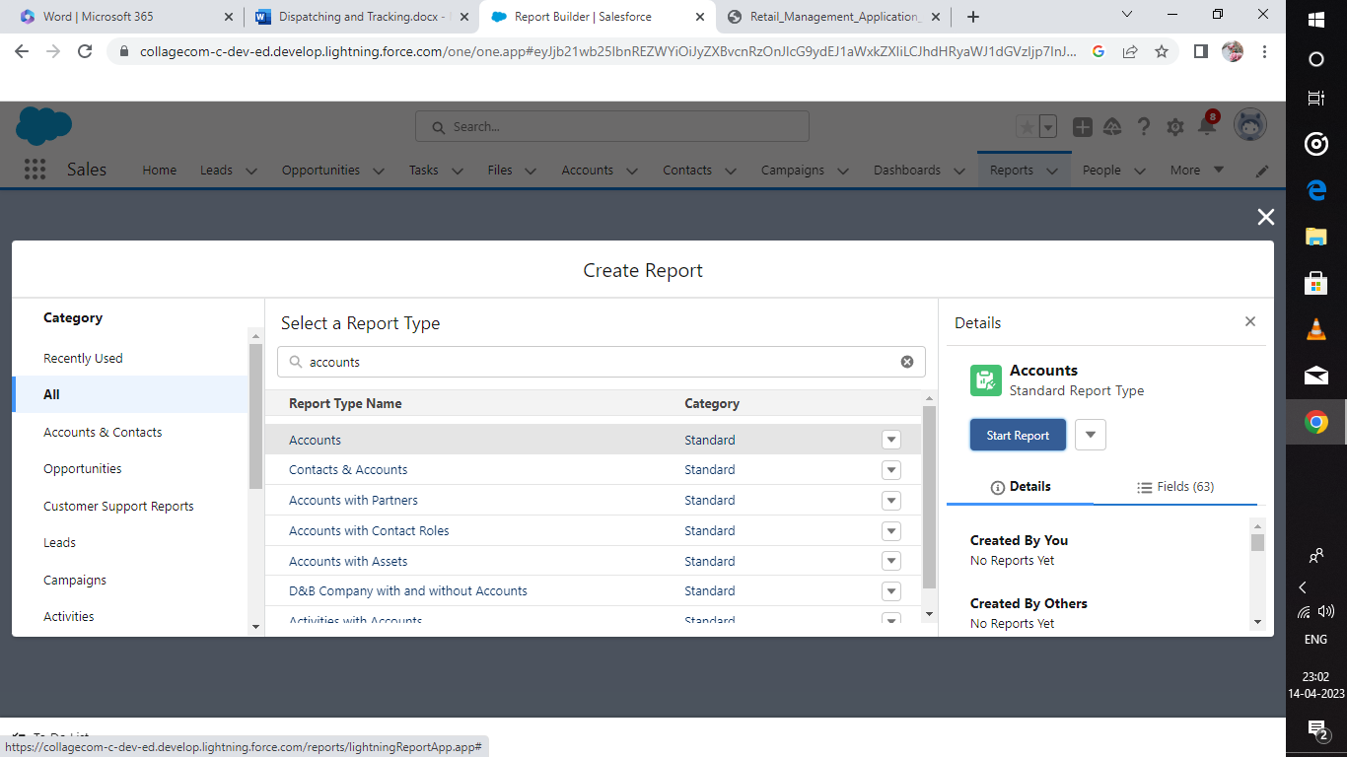

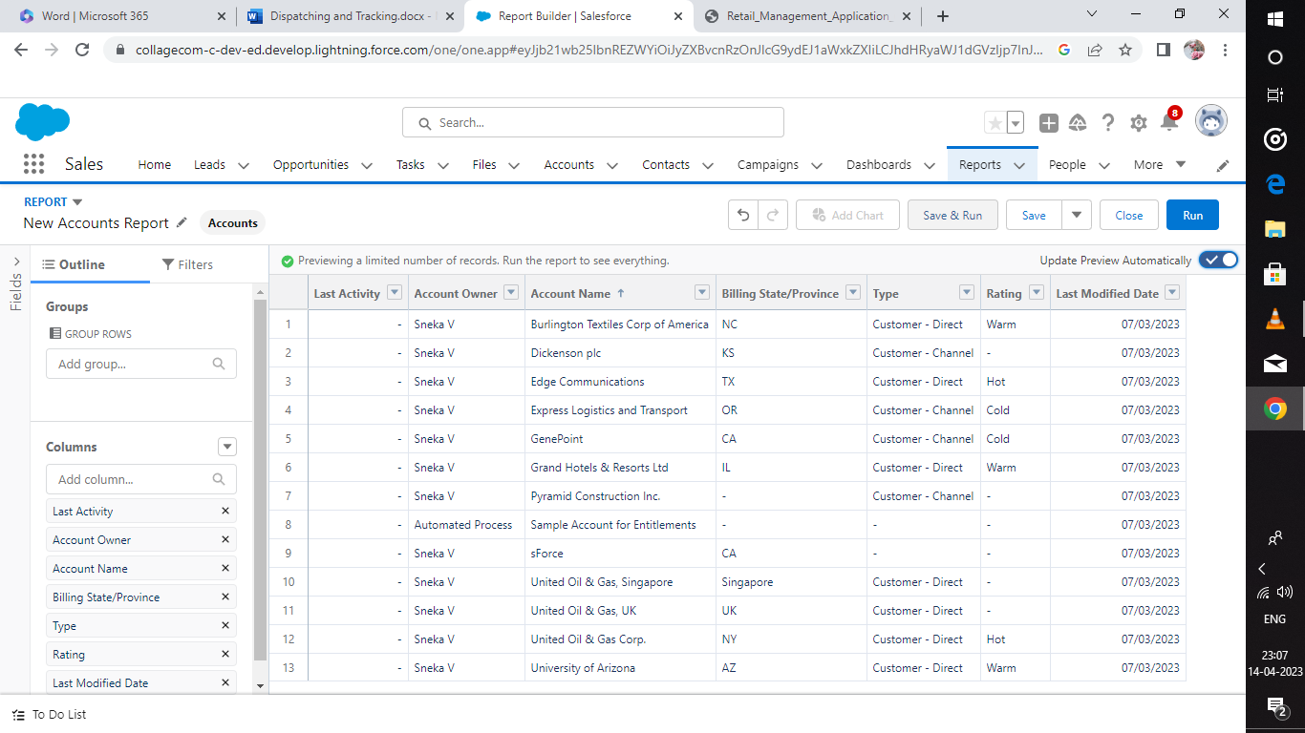

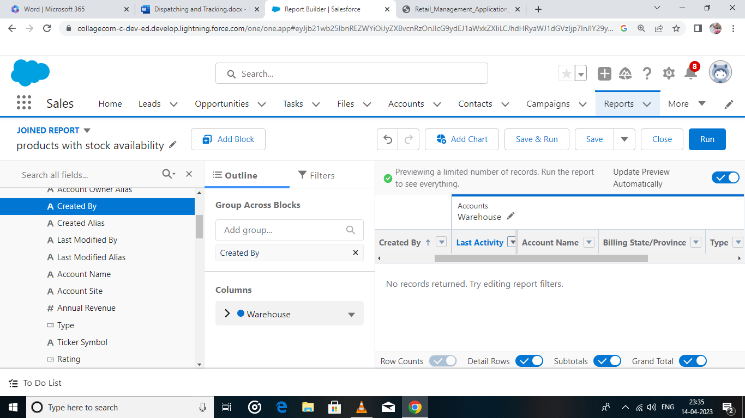

**Milestone-8 Dashboards:**

**Activity**

**Creation of Dashboard**

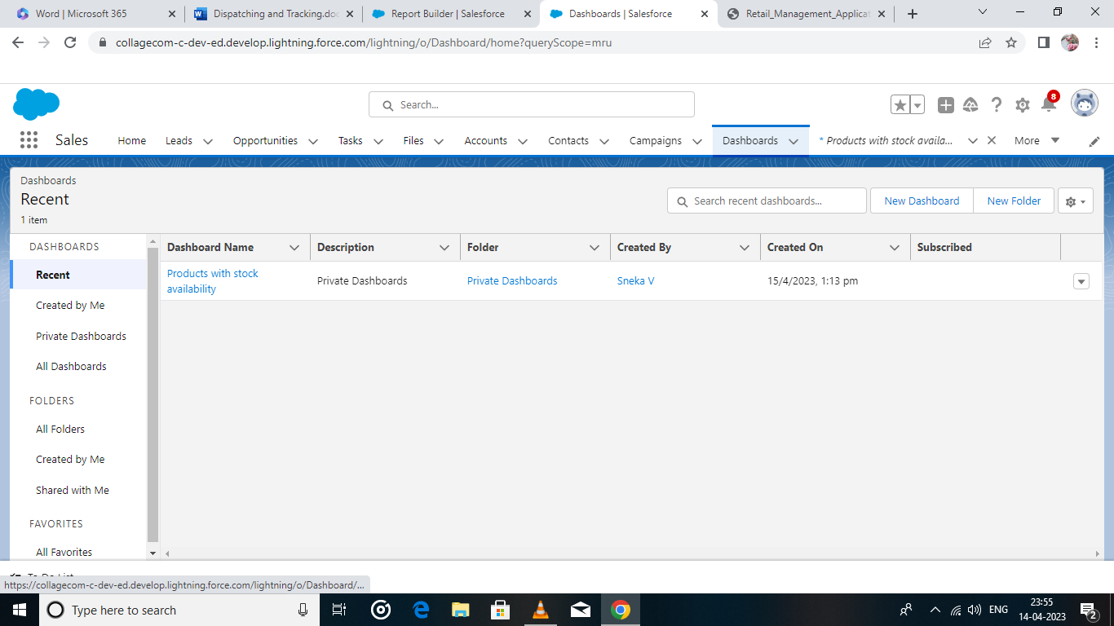

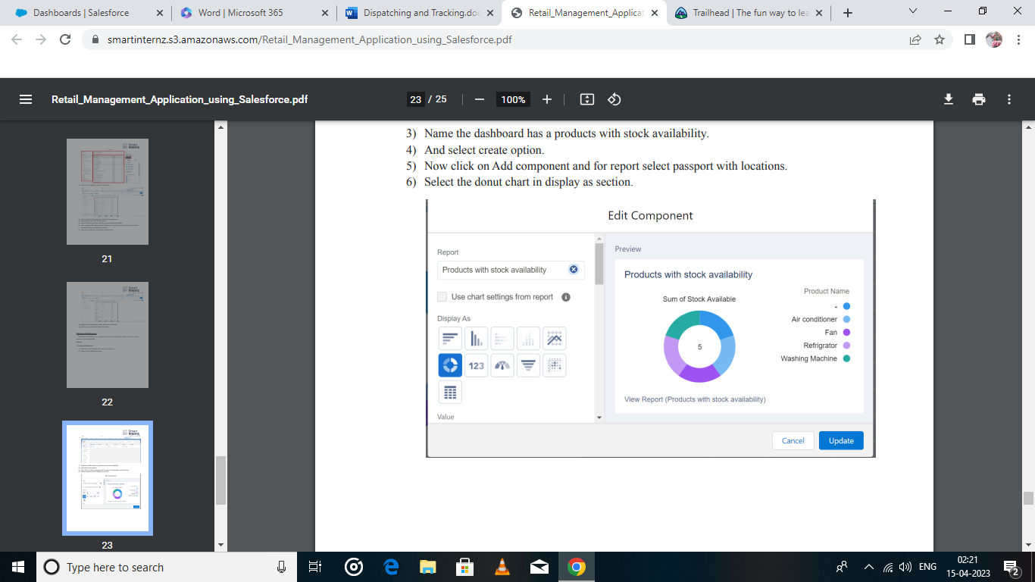

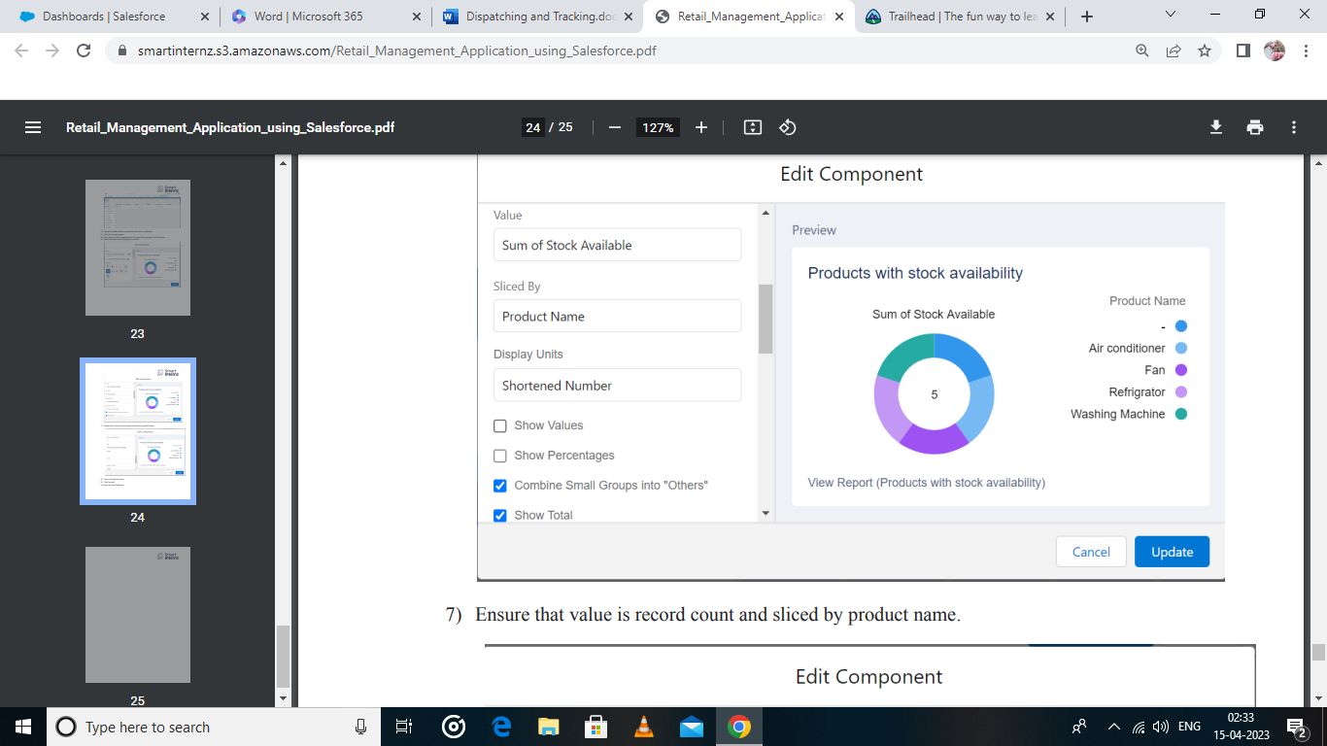

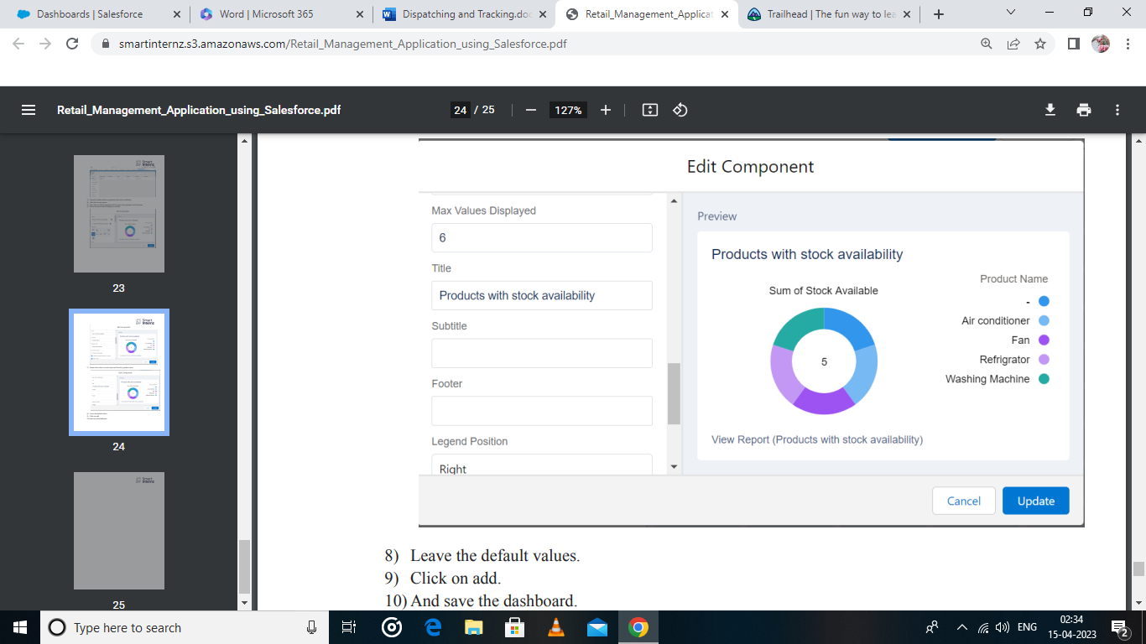

**4 TRAILHEAD PROFILE PUBLIC URL**

Team Lead - <https://trailblazer.me/id/snekv>

Team Member 1 - <https://trailblazer.me/id/srimj4>

Team Member 2 - <https://trailblazer.me/id/srimj4>

Team Member 3 - <https://trailblazer.me/id/ranjp10>

**5 ADVANTAGES AND DISADVANTAGES**

**Advantages of Retailers:**

* Requires less capital
* More profit Margin than wholesalers
* Better customer Relation

**Disadvantages of Retailers:**

* Requires more marketing costs
* Good selling skill is required.
* High competition.

**6 APPLICATIONS**

* Retail Management optimizes internal processes such as inventory management.
* This offline and online storefronts, warehouse operations, payment and accounting, and human resources.
* Retail Management improves overall company version.
* Retail store management improves customer experience and boosts customer satisfaction.

**7 CONCLUSION**

In conclusion, Salesforce is the powerful platform and enhance the app.

**8 VIRTUAL SCOPE**

* Virtual shopping.
* Omnichannel customer journeys.
* Experiential retail.